Step 1: Firstly, we have to install Java Development Kit (JDK) from <https://www.oracle.com/java/technologies/downloads/>. Then proceed the installation procedure.

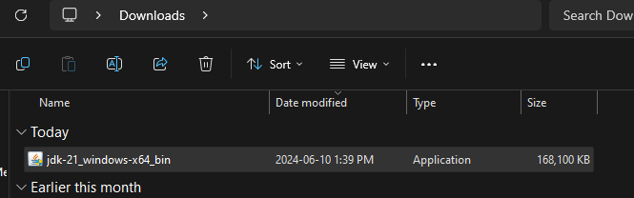

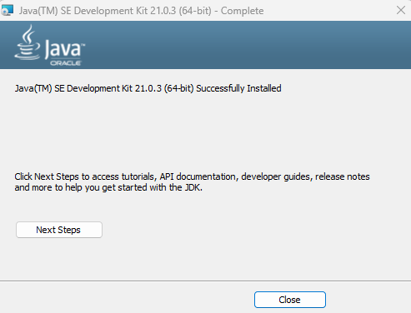

Step 2: Now, we should setup environment variables and set the path where JDK is installed and click OK.

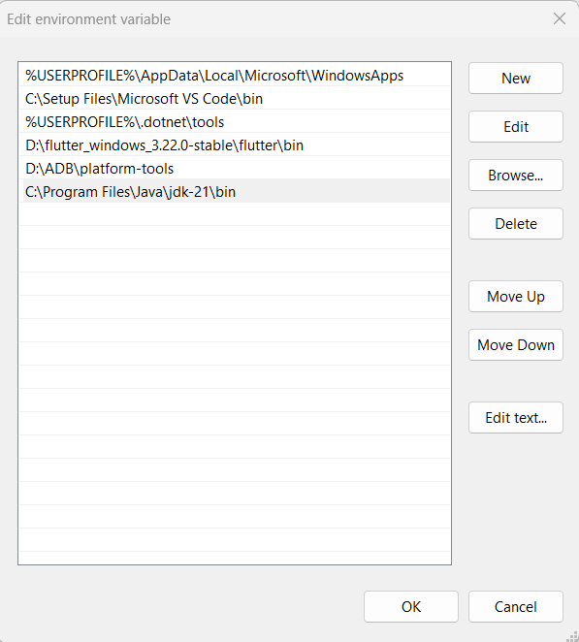

Step 4: Now, we should download the latest version of Android Studio from https://developer.android.com/studio.

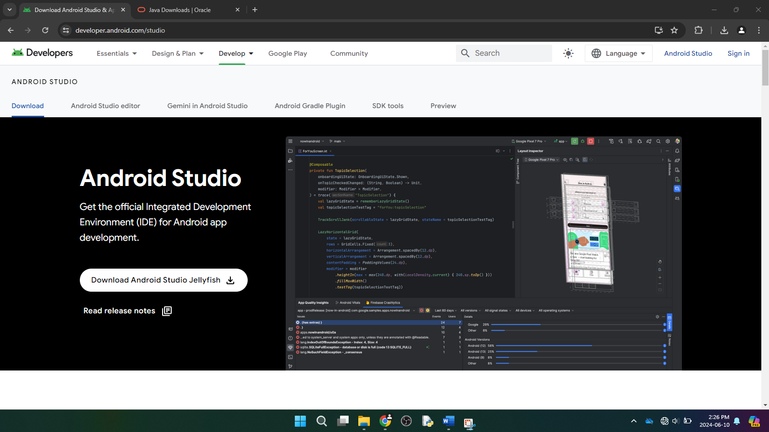

Step 5: We should agree the terms and conditions and click on Next until the Install button appears and Click on Install.

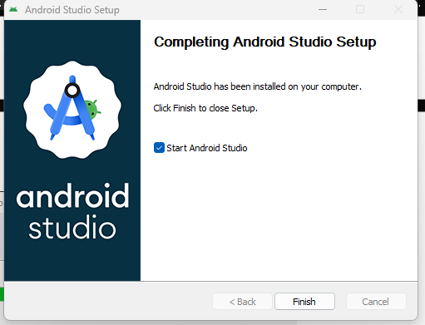

Step 6: After installation, following window appears.

Step 7: Then, we should choose the type of setup we want for Android Studio, click Next and click on Accept to accept the license agreement.

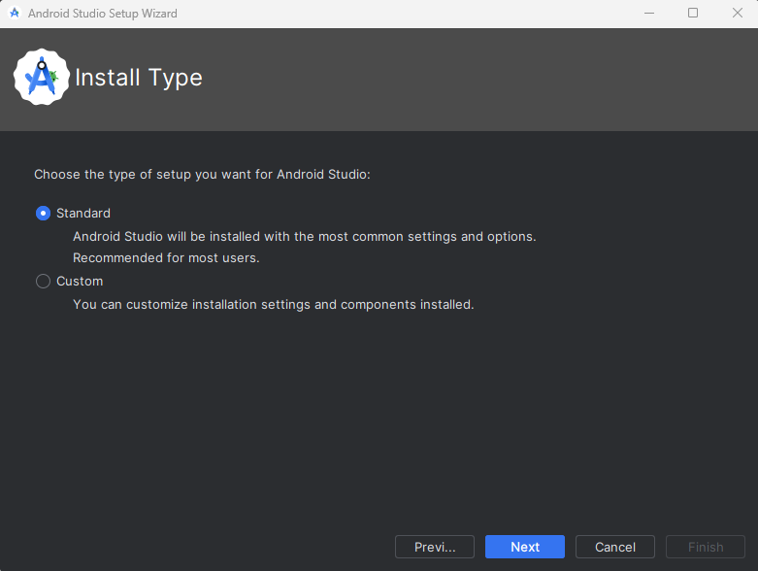

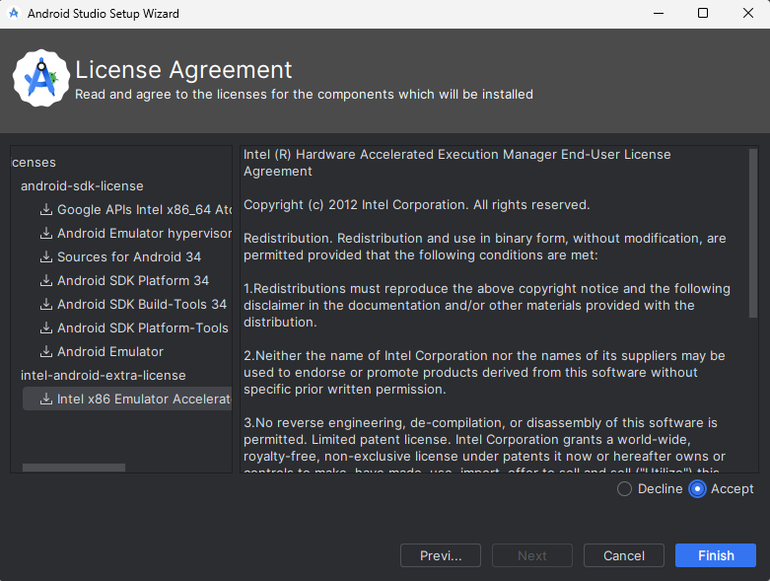

Step 8: Launch the application.

Step 9: Click on No Activity and Next to create a new project.

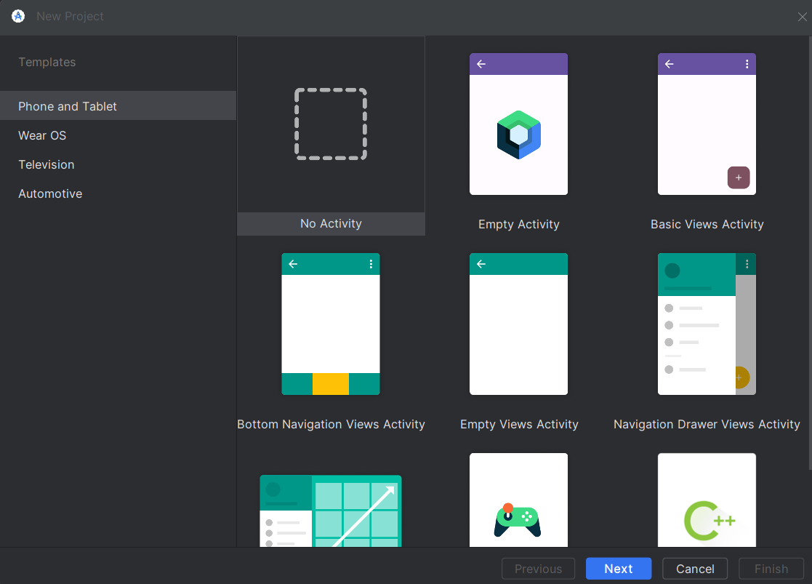

Step 10: Give the appropriate name, package name, location to be saved, language, minimum SDK, build configuration language and click on Finish.

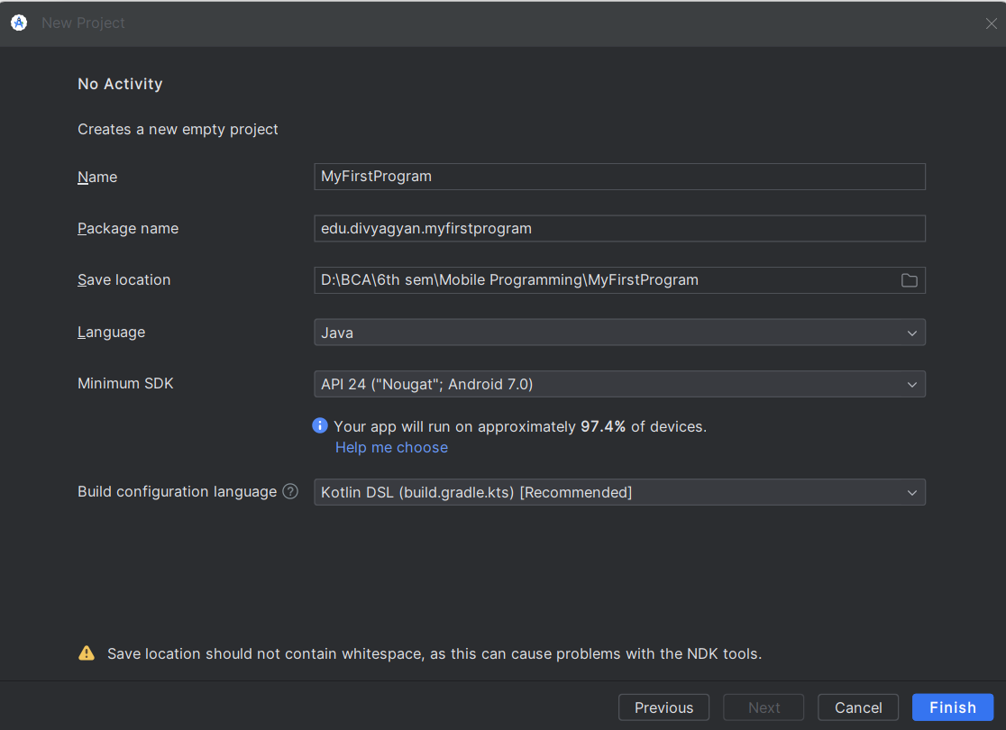

Step 10: Then go to settings and configure SDK Platforms and SDK Tools.

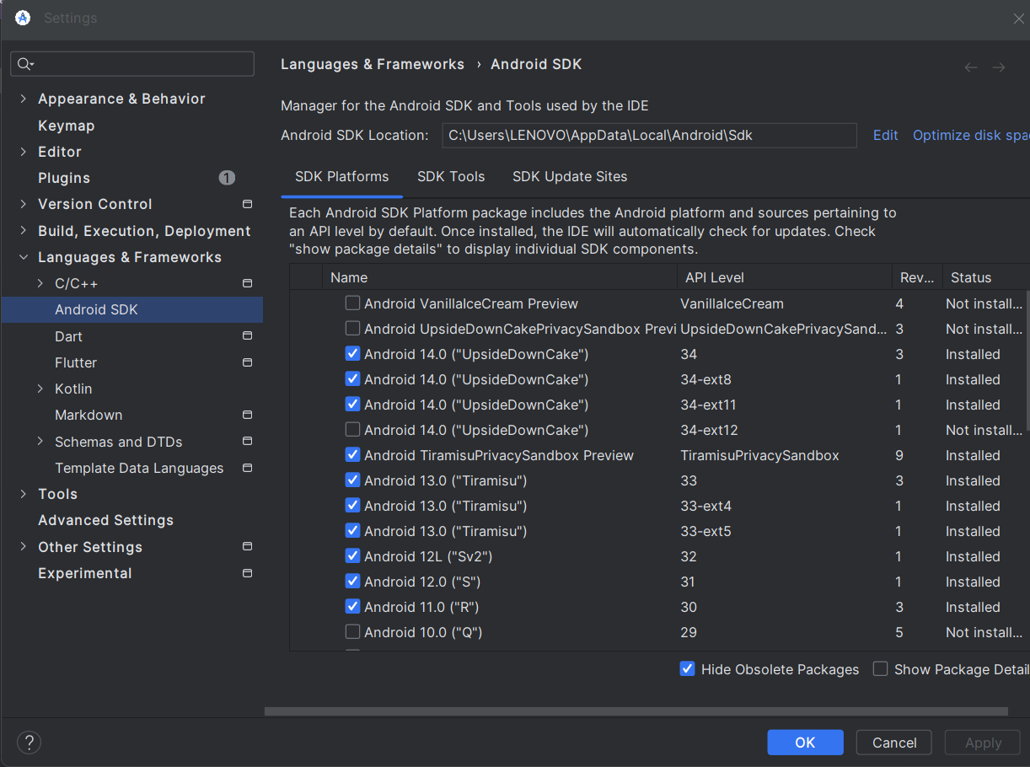

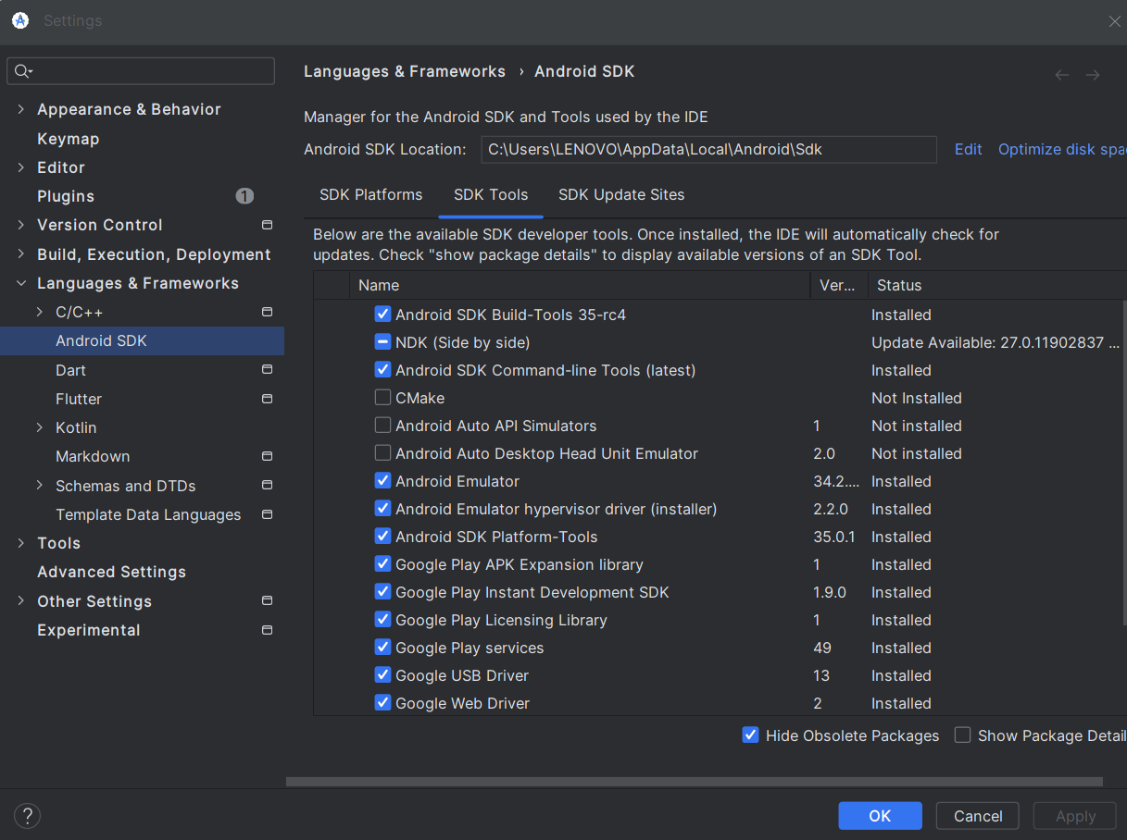

Step 11: Open the Device Manager by clicking Tools > Device Manager.

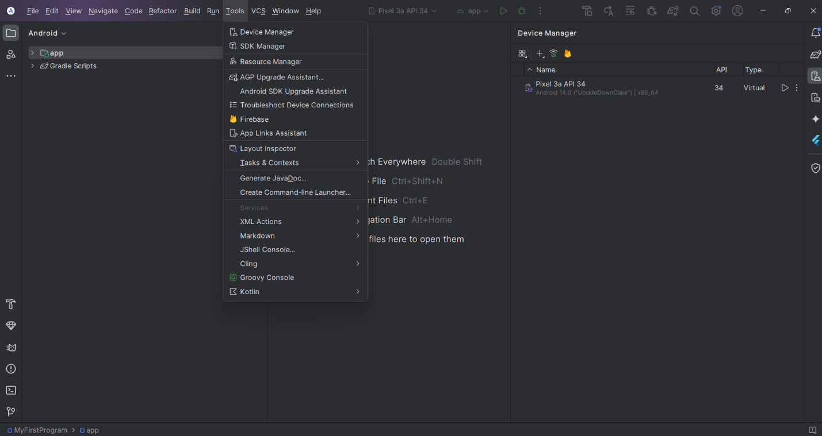

Step 12: Click on add icon and then on Create Virtual Device.

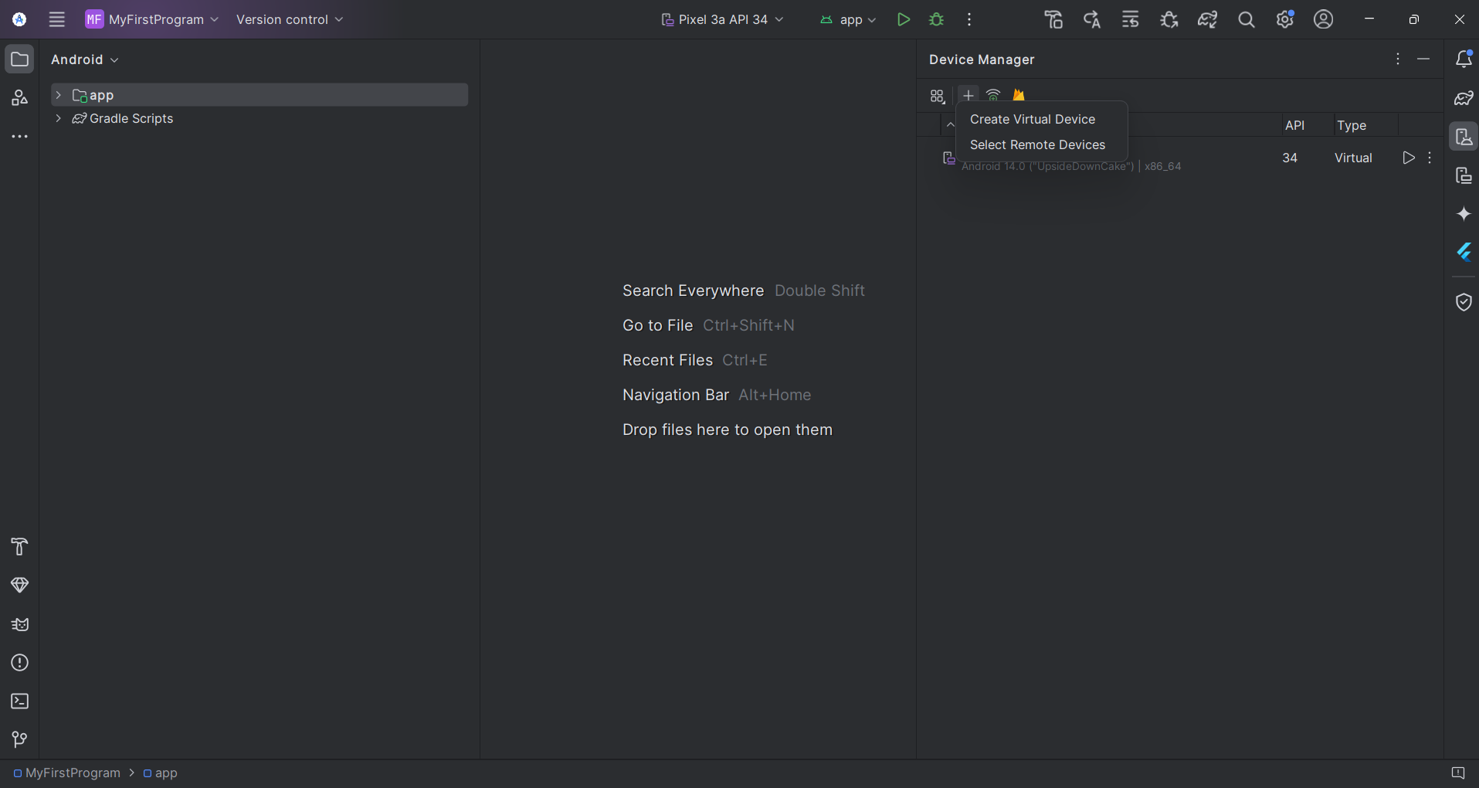

Step 13: Select a hardware profile and then click Next.

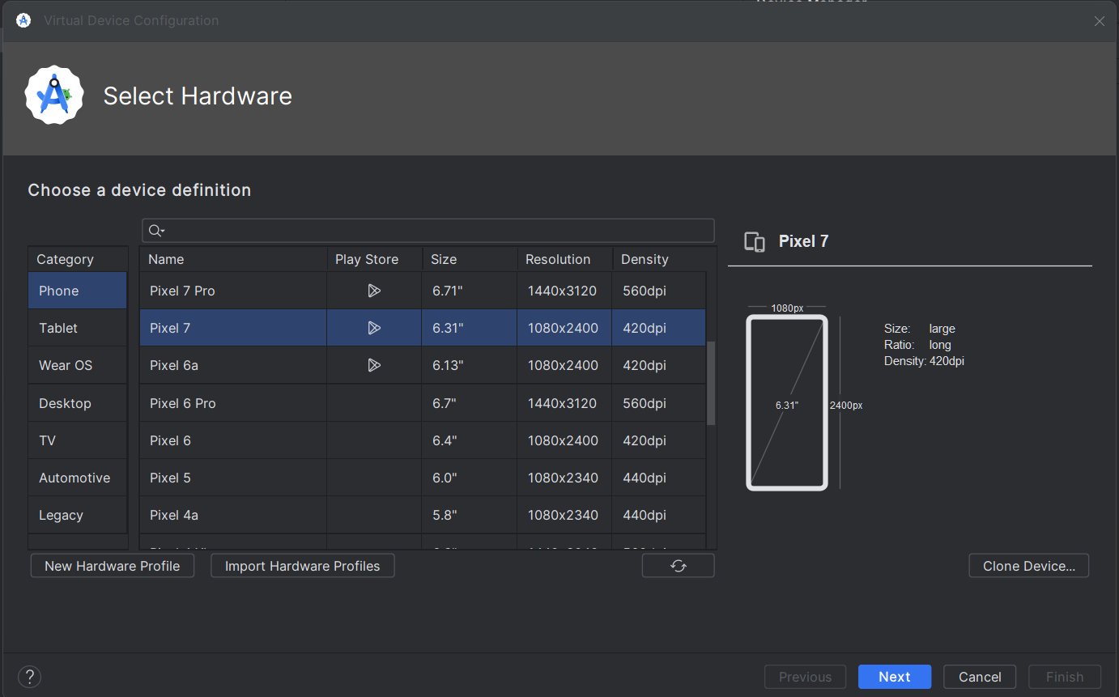

Step 14: Select a system image and then click Next.

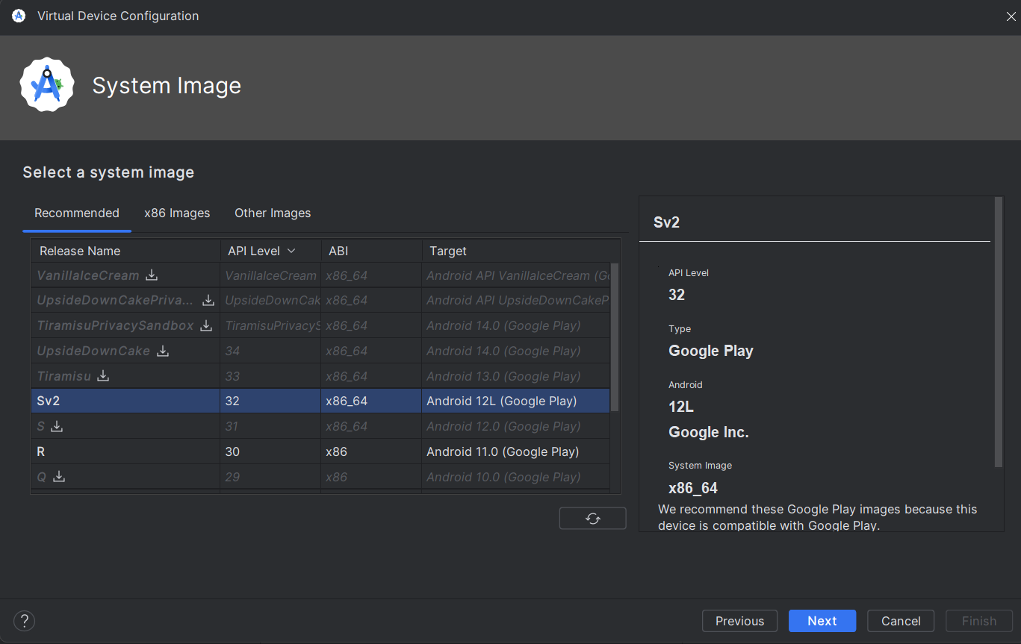

Step 15: Change AVD properties if needed, and then click Finish. The virtual device is then created.

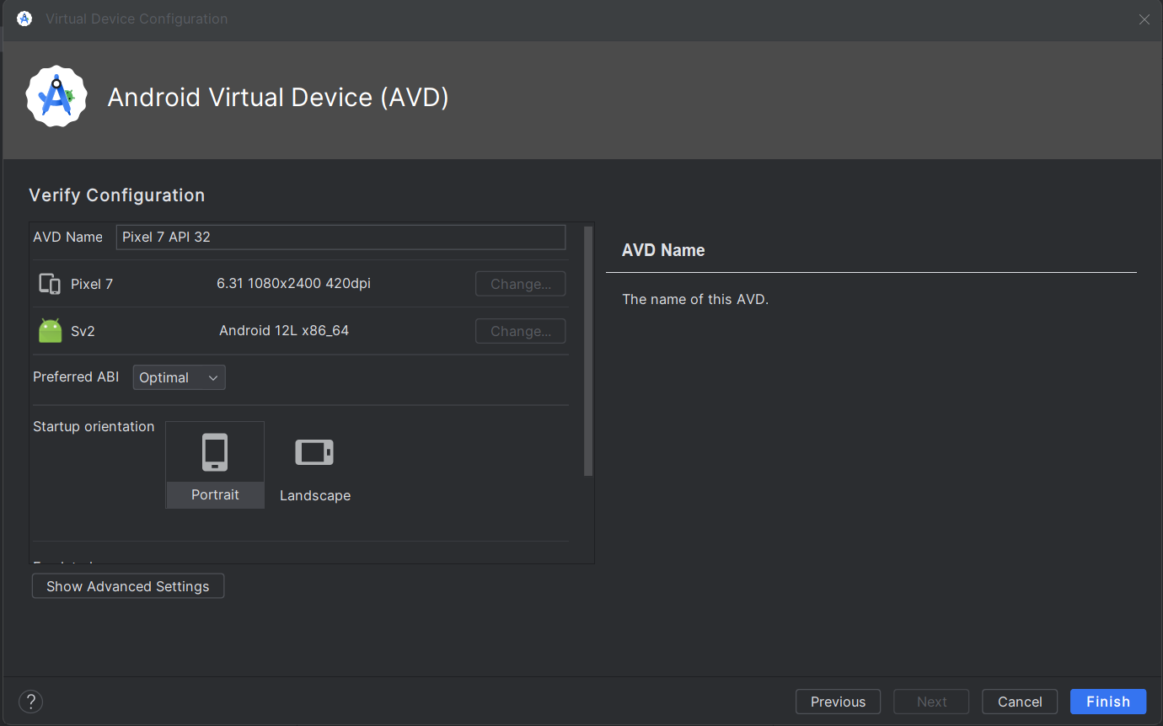  
In the toolbar, choose the AVD to run our app from the target device from the drop-down menu.

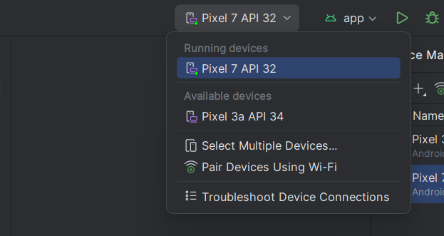

Click Run. Finally, our virtual device is ready to run our android app.

